AZURE COMMAND LINE INTERFACE(CLI)

What is Azure CLI?
Azure CLI (Command-Line Interface) is a command-line tool provided by Microsoft to manage Azure resources and services directly from your terminal or command prompt. It allows you to perform various tasks like creating, managing, and monitoring Azure resources without using the Azure Portal.
Azure CLI Features:
- The Azure CLI offers many great features for managing Azure resources.
Cross-Platform: You can install Azure CLI on Linux, Mac, or Windows computers.
Multiple Shell Environments: Azure CLI works in multiple shell environments, such as Windows Command prompt, Bash, and PowerShell.
Bash-like Syntax: If you are a Linux administrator, the Azure CLI syntax is similar to Bash scripting. This similarity helps Azure CLI feel more natural and easy to learn.
Automation: You can automate Azure management tasks by writing scripts with Azure CLI, such as creating, modifying, or deleting resources.
Open-Source: Microsoft hosts the source code for Azure CLI in GitHub, and community members can contribute to the project.
Azure CLI can also work with infrastructure as code languages like ARM templates and Azure Bicep.

Azure CLI Commands:
We need to open Windows Powershell to execute the azure-cli commands.
- Authentication & Account Management:
- az login : Log in to azure account
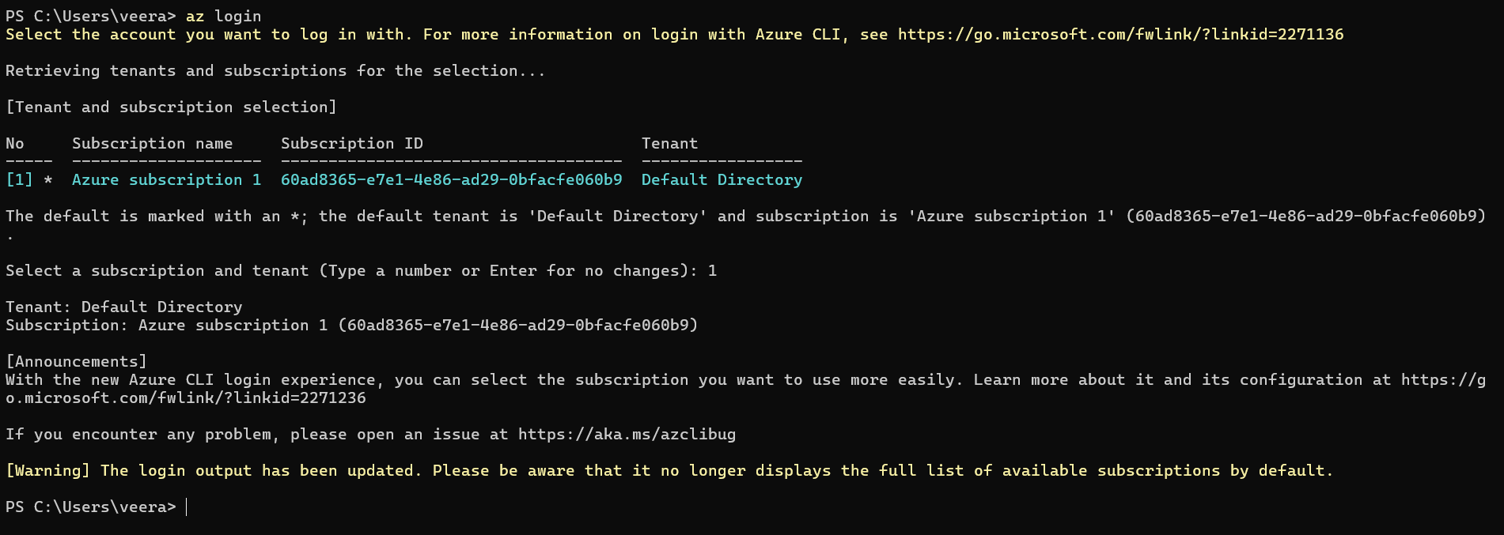
- az account show: Show the details of the account.
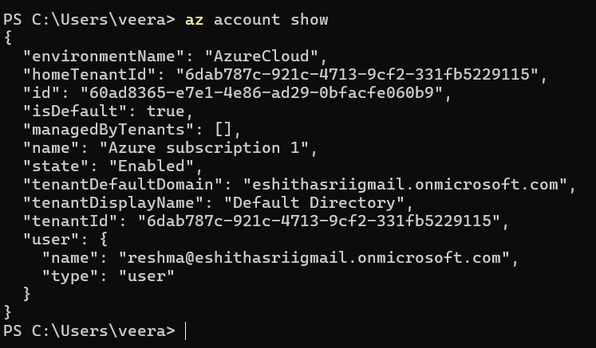
- az account set --subcription “60ad8365-e7e1-4e86-ad29-0bfacfe060b9”
- az account show --output=table: It gives the output in the tabular form.
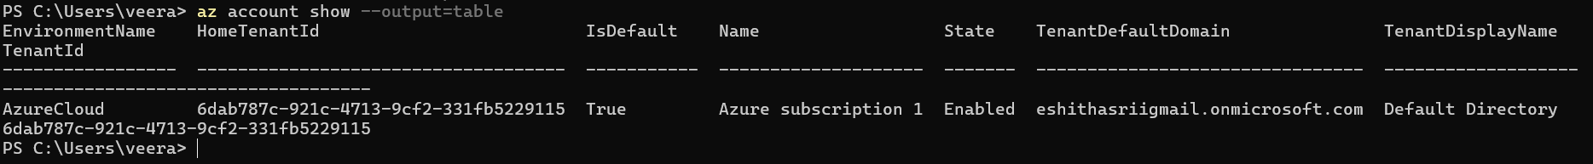

- Creating resource group in Azure microsoft using Azure cli commands:
- Az group create -l (location name) -n (resource group name): It creates resource group in the Microsoft Azure portal.
- az group list: List all the resource groups.
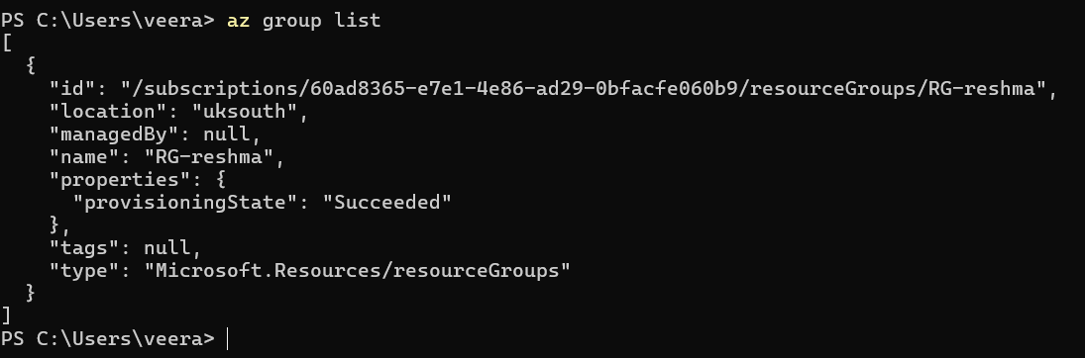
- az group update -n (resource group name) --tags SG=DevOpsIntern: It update the Tags in the resource group as DevOpsIntern.
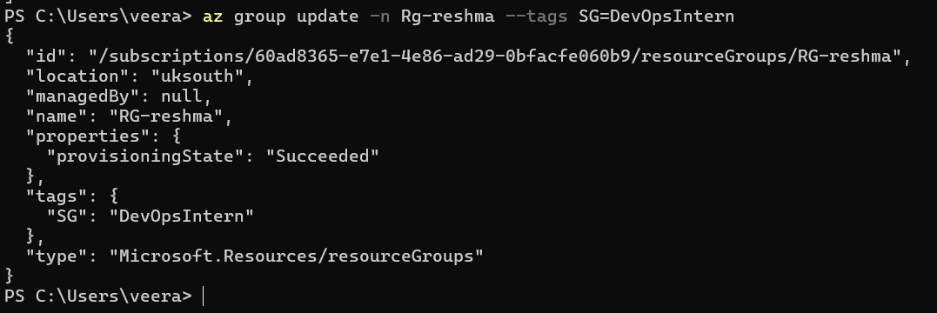
- Az group delete -n (resource group name): It deletes the resource group.

- Creating AppService Plan:
- Az appservice plan create -g (resource group name) -l (location) -n (appserviceplan name) : creates appservice plan in resource group.
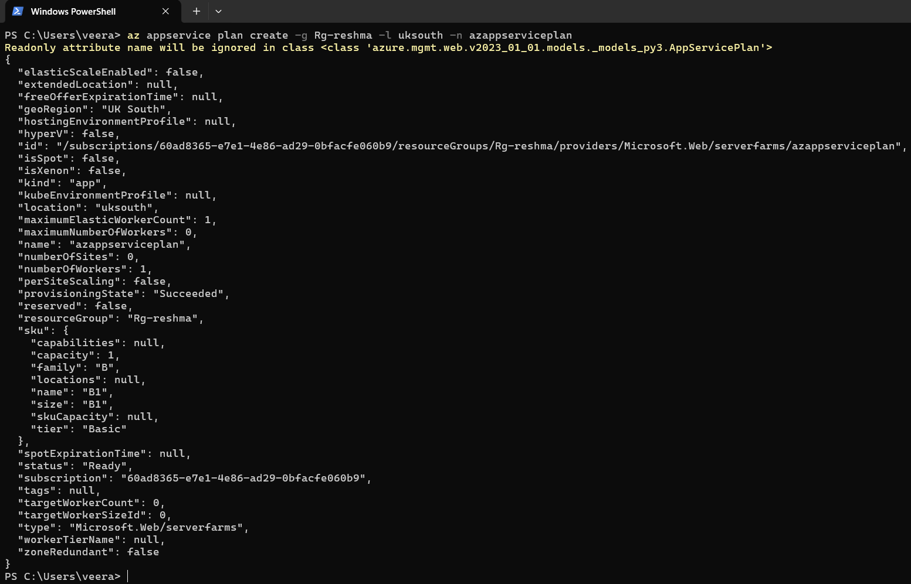
- Az appservice plan delete -g (resource group name) -n (appserviceplan name) : It deletes the appservice plan in the resource group.
- Creating AppService(Webapp) in the AppService Plan:
- Az webapp create -g (resource group name) -p (appserviceplan name) -n (webapp name) : It creates Webapp in appserviceplan.
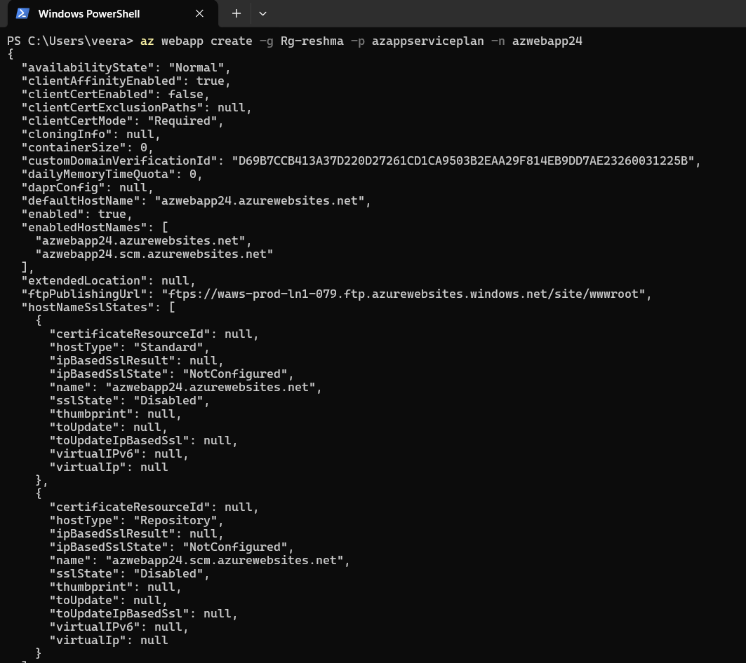
- az webapp delete -g (resource group Name) -n (Name0ftheWebAPP): It deletes the appservice or webapp.
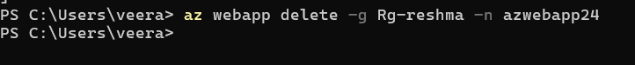
- Creating Storage account:
- Az storage account create -g (resource group name) -l (location) -n(storage account name) : It creates the storage account in the resource group.
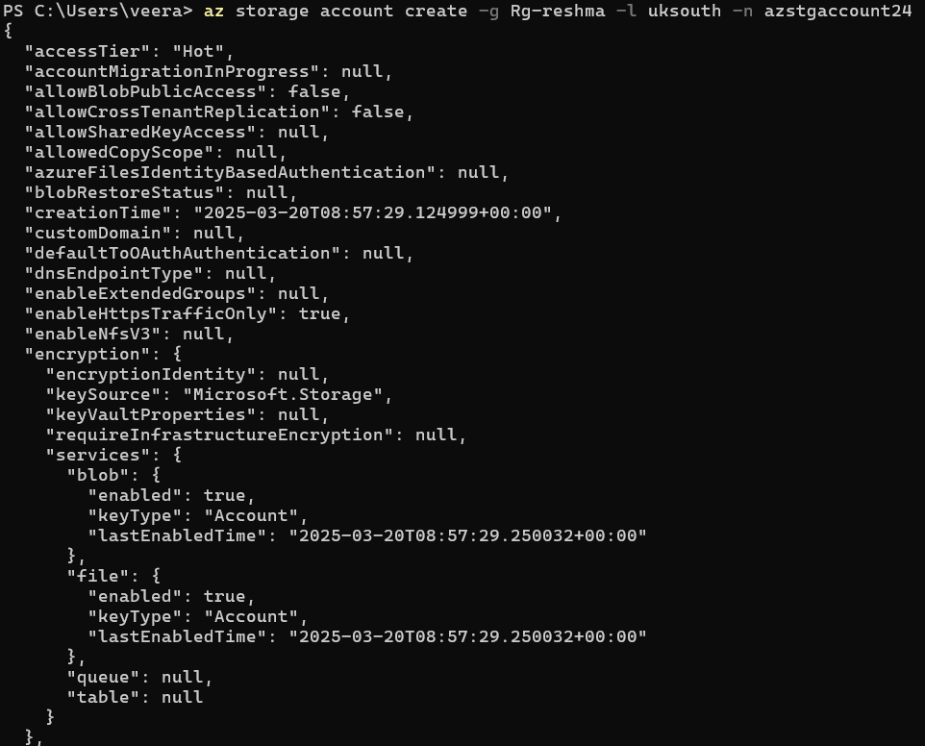
- Az storage container create -n (name of the container) --account-name (Storage account name) : It creates the container in the Storage account.
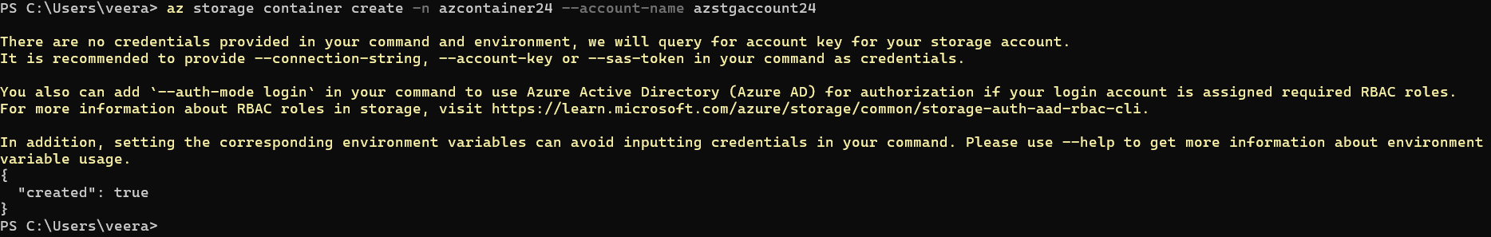
- Az storage container delete -n (name of the container) --account-name (Storage account name) : It Deletes the container in the stoarge account.
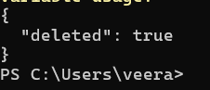
- Az storage account delete -g (Resource group name) -n (Name of the storage account) : It deletes the Storage account in the resource group.
- Creating KeyVault :
- Az keyvault create -g (resource group name) -l (location) -n(name of the keyvault) : It creates the keyvault in the resource group.
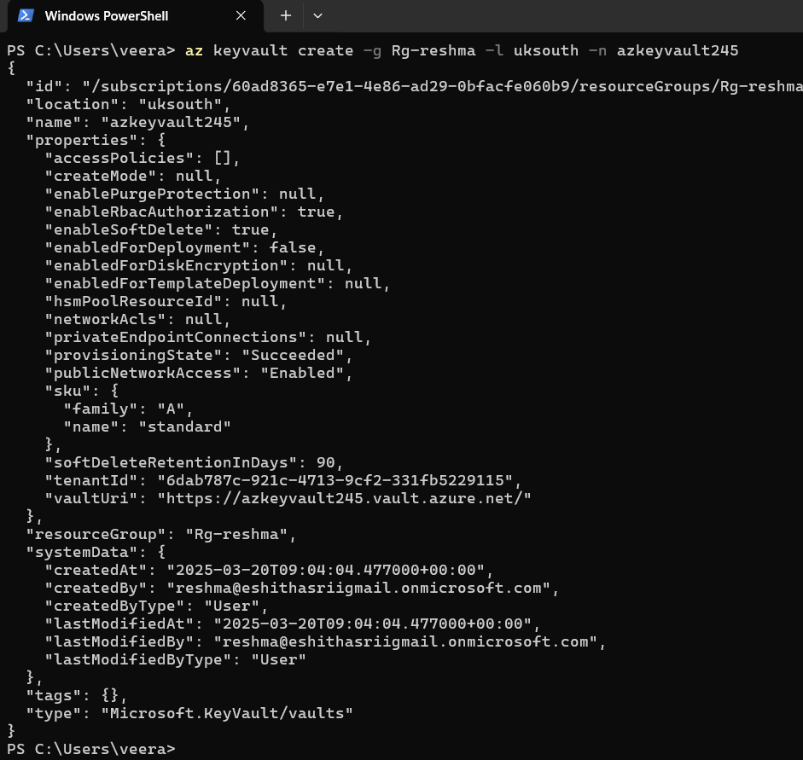
- Az keyvault list: It lists the Keyvault account.
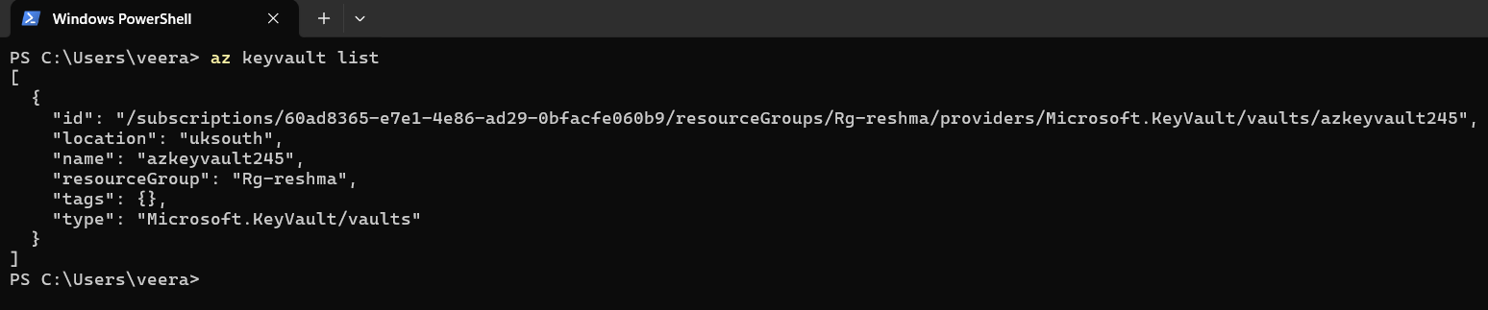
- Az keyvault delete -g (resource group name) -n (name of the keyvault) : It deletes the keyvault in the resource group.

My resources:
